

**MARKING GUIDE**

**GEOGRAPHY**

**(World Problems and Development)**

***Impression summary***

*Totally irrelevant / out of context. 00*

*Poor answers 1 – 7*

*Inadequate / O-level 8 – 10*

*Marginal answer 11 – 13*

*Basic answer / A – level 14*

*Average 15 – 16*

*Good answers 17 – 19*

*V.Good answers 20 – 22*

*Excellent answers 23 – 25*

***SECTION A : STATISTICS***

1. *Study table* ***1*** *below, showing population for selected countries (1990 – 2006) and answer the questions that follow:*

|  |  |  |
| --- | --- | --- |
| ***COUNTRY*** | ***POPULATION IN (‘000’)*** | |
| ***1990*** | ***2006*** |
| *Zimbabwe* | *10,500* | *13,200* |
| *Egypt* | *55,100* | *74,200* |
| *Republic of South Africa* | *35,200* | *47,400* |
| *Ghana* | *15,600* | *23,000* |
| *Algeria* | *25,300* | *33,400* |
| *Total* | *141,700* | *191,200* |

*Adapted : 2008 World Development Indicators*

*The World Bank, Washington DC pp40 – 42*

1. *Draw a compound bar graph to represent the information in the table.*

*(09 marks)*

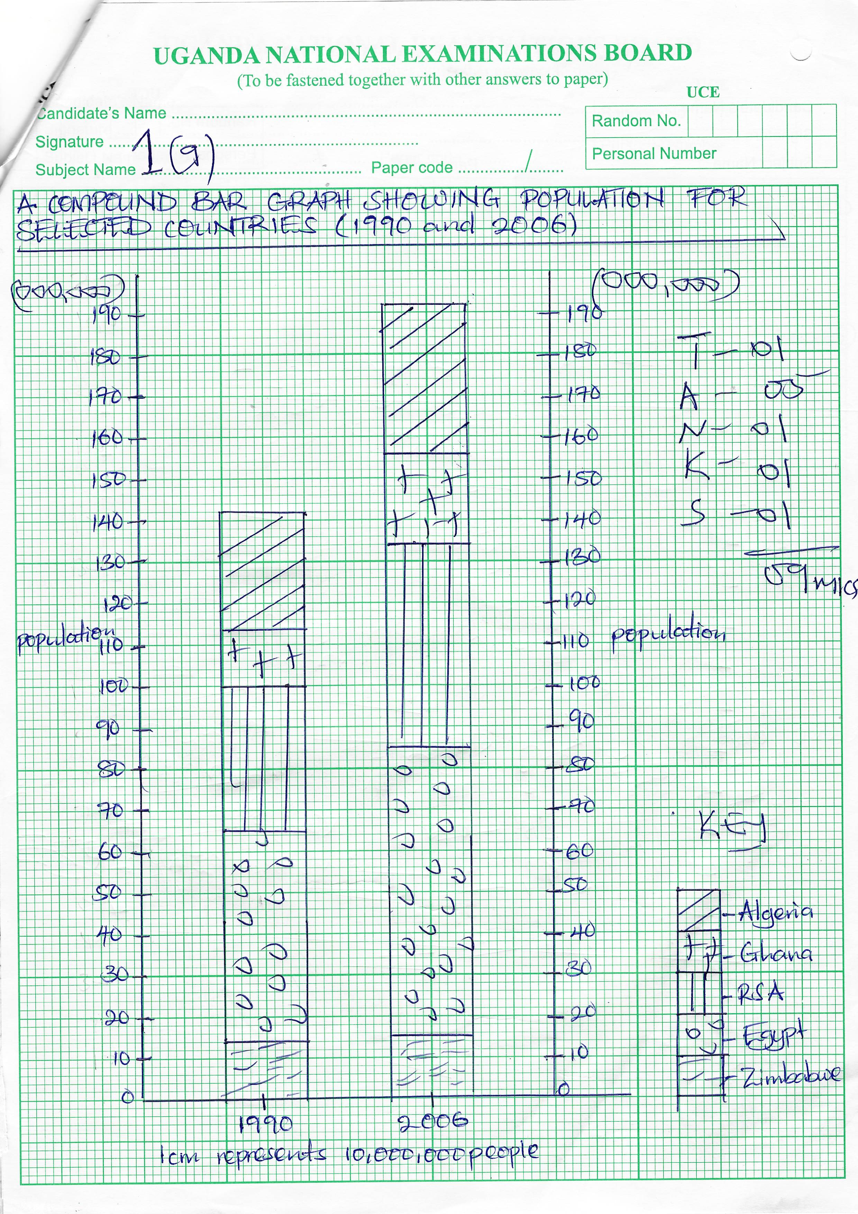

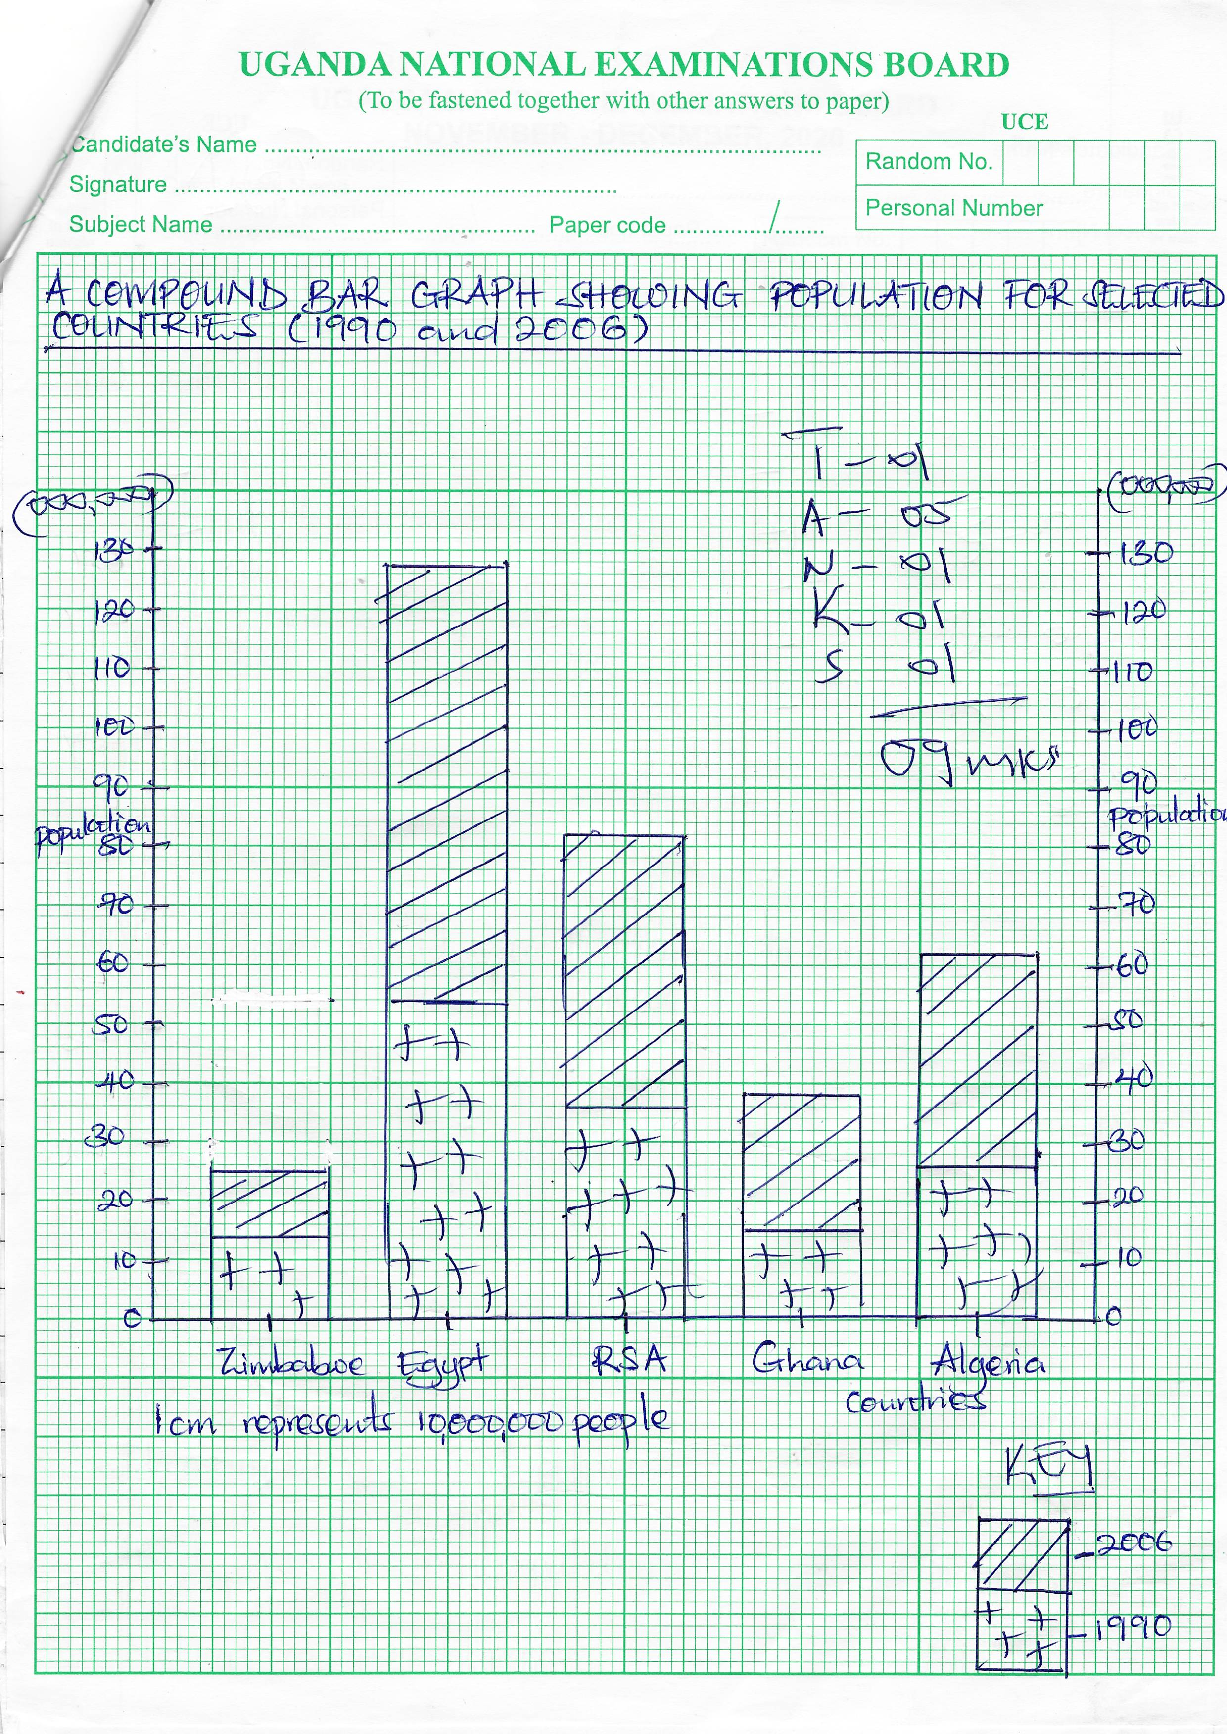

1. *State the demerits of using the method in (a) above. (03 marks)*

* *Occupies large space*
* *Consumes a lot of time*
* *Difficult to get the scale because of large amplitude*
* *Congested*
* *Involves a lot of calculations*
* *Difficult to tell absolute values.*

1. *Identify the country with the;*
2. *Highest* 
   * + *Ghana*
3. *Lowest, percentage population increase. (02 marks)* 
   * + *Zimbabwe*
4. *(i) Explain the causes of rapid population increase in the country*

*identified in (c) (i) above. (06 marks)*

* *Candidates should select one country to earn a mark*
* *Causes of rapid population increase*
* *Improved medical and health care*
* *Influence of polygamy*
* *Early marriages*
* *Increased food production*
* *Religious beliefs*
* *Cultural factors*
* *Difference in sex ratio*
* *High fertility rates among the women*
* *Illiteracy / low levels of education*
* *Unfavourble government policies*
* *Influence of immigration*
* *Poverty among the rural population*
* *Political stability*
* *Natural population increase*

*(ii) Suggest measures that should be taken to reduce the rapid population increase in the country identified in (c) (i) above. (05 marks)*

* *Candidates should select a country to earn a mark*
* *Encourage use of family planning methods*
* *Sensitize the masses on dangers of large population*
* *Increase the age of marriage*
* *Prolong the education period*
* *Encourage monogamy*
* *Discourage immigration*
* *Giving incentives to small families*
* *Strong policies against traditional practices.*

***SECTION B***

1. *Account for the development of extensive farming in either the prairies of North America or the Pampas of South America. (25 marks)*

*Identify the type of farming, characteristics, type of crops / animal breeds*

***EITHER***

*The prairies of North America*

*Factors favouring wheat growing*

***Physical factors***

* *Extensive cheap land for establishment of farms*
* *Relatively flat, gently sloping landscape*
* *Presence of fertile black chernozem soils*
* *The suitable climatic conditions e.g. heavy rainfall*
* *The original / extensive temperate grassland vegetation which was easy to clear*
* *Abundant supplies of water from rivers and lakes for irrigation*
* *Pests and diseases*

***Human factors***

* *Presence of adequate and efficient transport routes*
* *Presence of adequate capital for investment*
* *Extensive farming developed as a result of large supplies of market*
* *The scientific researches undertaken*
* *Large supplies of manpower both skilled and unskilled to work on wheat farms.*
* *Large supplies of manpower both skilled and unskilled to work on wheat farms.*
* *The relative political stability for investments*
* *The supportive government policies encouraging wheat growing*
* *What growing developed because of the large supplies of power / energy*
* *Presence of well – organized and efficient cooperatives*
* *Presence of numerous wheat processing industries*
* *Presence of modern technology e.g. elavators*
* *Modern storage facilities for the wheat.*
* *Impact of Early European settlers*

***Impressional marking***

***OR***

*The pampas of South America*

*Factors favouring ranching in the pampas*

***Physical factors***

* *The gently sloping landscape for easy movement of animals*
* *Presence of large and extensive land*
* *The presence of poor and infertile soils*
* *The presence of a maritime type of climate ideal for livestock farming*
* *Availability of constant supplies of water for the animals*
* *Presence of natural grasslands / pastures for the animals*
* *Low incidence of pests and diseases*
* *Presence of high quality animal breeds*
* *The strategic location at the coast for easy marketing*

***Human factors***

* *Availability of large and ready market*
* *Presence of large supplies of skilled labour*
* *Availability of adequate capital for investments*
* *Presence of efficient transport and communication network*
* *Presence of favourable government policies*
* *Long culture of cattle rearing of the people*
* *Presence of improved technology e.g. Machines*
* *Introduction supplementary feeds*
* *The use of scientific management of animals*
* *Establishment of processing industries to process products*
* *Land reform policies which led to consolidation of land*
* *Intensive research led to the development f ranching*
* *Presence of efficient, well organized cooperatives*
* *Political stability for investments.*

*(25 marks)*

1. *Explain the significance of Horticulture to the development of either the Netherlands or Kenya. (25 marks)*

*Candidates should define horticulture, select a country and give major characteristics of horticulture.*

*Identify the major areas of horticulture and examples of crops.*

*The significance are more or less similar.*

***Positive significance***

* *Provision of food for the urban population*
* *Provides revenue for the government for development*
* *Promotes economic diversification, widening tax base*
* *Promotes research / scientific methods of farming*
* *Promotes international trade and relations*
* *Development of transport routes e.g. railways, road, air transport, water transport,*
* *Encourages the development of urban areas*
* *Encourages the development of social services e.g. electricity pipe water, health etc*
* *Foreign exchange earnings for investments*
* *Improves on the technological innovations*
* *Acquisition of skills*
* *Reclamation f idleland for farming*
* *Development of industries*
* *Employment opportunities helping to ease income.*

***Negative contributions***

* *Pollution from pesticides / insecticides and from industrial wastes*
* *Urban related problems e.g. high crime rates, congestion*
* *Technological unemployment promoting crime*
* *High costs of farming and transport of agricultural products*
* *High loses incase of natural hazards due to perishable of the products*
* *Encourages soil exhaustion due to monoculture*
* *Leads to loss of bio-diversity*
* *Profit repatriates with associated problems*

*Impressional marking*

*(25 marks)*

1. *(a) Distinguish between purse seining and drifting methods of fishing.*

*(10 marks)*

*Candidates should distinguish between purse seining and drifting methods of fishing.*

***Purse seining***

* *It is used for catching demarsal fish*
* *Two boats are sued to cast the net which has got floats and weights*
* *One boat moves and encircles the fish shoal which are trapped by their gills. Used for catching fish species like hake, halibut, cod etc.*

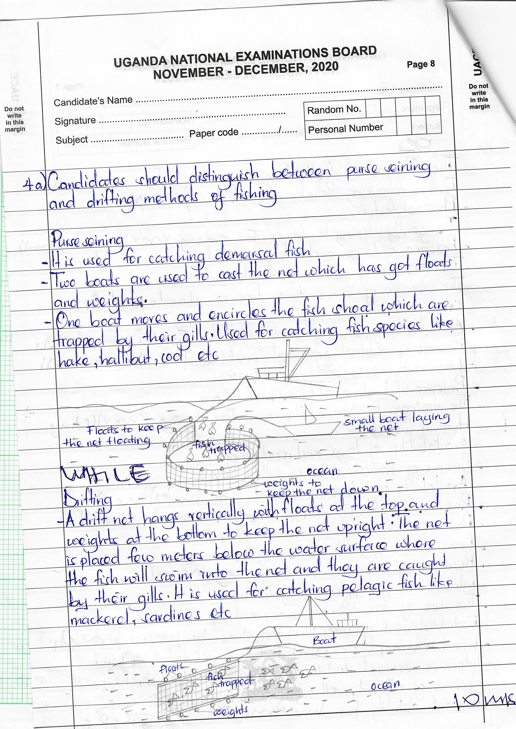

***WHILE***

*Drifting.*

* *A drift net hangs vertically with floats at the top and weights at the bottom to keep the net upright. The net is placed few meters below the water surface where the fish will swim into the net and they are caught by their gills. It is used for catching pelagic fish like mackerel, sardines etc.*

**

*(b) Account for the development of the fishing activities in anyone country in the North West Atlantic fishing ground. (15 marks)*

* *Candidates should define fishing and select one country in North West Atlantic fishing ground (USA or Canada). Identifying fishing methods, fish species and the fishing ports.*
* *Explain the factors favouring fishing*

***Physical***

* *Existence of a large water body / fishing grounds*
* *Presence of numerous rivers, coastal creeks and fiords for fish breeding*
* *Presence of extensive and shallow continental shelf*
* *Presence of thin infertile soils which discourage arable farming*
* *Plentiful supply of planktons as the fish food*
* *Existence of a variety of commercially valuable fish species*
* *Presence of smooth sea ocean floor*
* *Presence of indented or rugged coastlines*
* *Cool climatic conditions / temperate climate ideal for fish breeding*
* *Rugged terrain and mountainous landscape*
* *The prevailing ocean currents / the mixing of the warm north Pacific currents.*
* *The existence of temperate forests*
* *Presence of numerous offshore islands*
* *The limited economic activities*

***Human factors***

* *Large capital for further investments*
* *Advanced technology for fish processing*
* *Existence of a wide and ready market for fish*
* *Intensified fisheries research to improve on the quality of fish*
* *Adequate manpower for fishing*
* *Presence of large supplies of energy resources*
* *Supportive / favourable government policies*
* *Numerous fishing industries that manufacture fishing equipment or gears*
* *The sea fairing tradition / the long standing culture of fishing*
* *Better methods of processing and storage*
* *Political stability for long term investment*
* *Religious factors limiting eating meat during lent*
* *Cooperatives in the major fishing ports for credit facilities*

*Impressional marking*

*(25 marks)*

1. *(a) Explain the term urbanization. (05 marks)*

* *Candidates should define the term urbanization, identify functions of urbanization and give examples of urban centres.*

*(b) Account for the development of either Addis Ababa or Johannesburg as an urban centre. (20 marks)*

* *Candidates should select either Addis Ababa or Johannesburg and explain factors for development which are more or less similar.*

***Johannesburg***

* *Found in the republic of South Africa and located in the Rand*
* *It is the largest city in South Africa and a major commercial centre with big population*
* *It is a terminal for air and railway transport*

***Addis Ababa***

* *It is found in Ethiopia and located in the highlands boarderign the great Rift valley*
* *It is the largest city in Ethiopia and a major commercial and cultural centre.*

***Factors for development***

* *Strategic location of the urban centres*
* *Presence of efficient transport and communication network*
* *Abundant water supply*
* *Historical factors i.e. Johannesburg*
* *Presence of gently sloping topography*
* *Government policy for urban development*
* *Technological advancement to construct bridges.*
* *Cultural function*
* *Presence of mineral deposits with attracted big population*
* *The relative political stability attracting investors*
* *Commerce and trade attracting many traders*
* *Favourable climate that attracts settlemtns*
* *Extensive land for expansion*
* *Presence of labour to work in the urban centre*
* *Availability of capital from government and foreign investors*
* *Power supply used in industries, mining areas and domestic use.*
* *Industrial inertia i.e. attracting many people*
* *Rich hinderland / productive / rich urban field*
* *Hard / firm foundation for construction of buildings*
* *Availability of social services e.g. schools, hospitals*
* *Influence of tourism.*

***Impresional marking***

***(25 marks)***

1. *Examine the challenges facing the mining industry in either the Democratic Republic of Congo or Algeria. (25 marks)*

*Candidates should define mining and select one country identify the mining region, mining methods, examples of minerals mined and the mining centres*

*The challenges facing the mining industry are more or less the same*

***Factors***

* *Conflict over ownership of mineral resources*
* *Political instabilities bring mining activities to a stand still*
* *Limited market for minerals / decline in demand*
* *Price fluctuation in the world market*
* *Poorly developed transport networks*
* *Thick vegetation cover in DRC limits the surveying, exploration and exploitation of minerals*
* *Unfavourable climatic factors*
* *Inadequate skilled labour which calls for dependence on exports from foreign countries who are expensive*
* *Poorly developed technology i.e. use of poor technology*
* *Limited capital resources for investing in the exploration and exploitation*
* *Profit repatriation by foreign companies*
* *Existence of mineals in small and scattered quantities*
* *Some minerals are of low grade and unprofitable to mine*
* *Nature of occurance of minerals or depth of minerals*
* *Accidents in mines which scares away labour*
* *Pollution of the environment especially water and air*
* *Inadequate power supply coupled with high costs of power*
* *Mineral exhaustion due to over exploitation*
* *Unsupportive government policies*
* *Limited research to improve uses of imeral*
* *Inadequate water supplies for exploitation and processing*
* *Strikes and demonstration which paralyses mining activities.*

*Impressional marking*

*(25 marks)*

1. *Describe the measures being taken to improve inland water transport in either China or United States of America. (25 marks)*

*Candidates should define transport and then identify the types of inland water transport and respective ports.*

*Measures being taken are more or less similar*

* *Construction of canals to bypass waterfalls, rapids*
* *Construction of locks to regulate water levels*
* *Construction of multiple dams to make rivers more navigable*
* *Constant dredging and de-silting*
* *Blasting and clearing of islands*
* *Constant ice breaking or defrosting of river courses*
* *Supplementing water transport with road and railway transport*
* *Use of high level of technology such as containerization*
* *Effective planning and time tabling*
* *Reduction in river utilization tariffs or taxes*
* *Promotion of economic activities in the hinterland*
* *Encouraging research and development on water transport*
* *Enlargement or widening of the river channels*
* *Straightening of the river courses to remove sharp bends*
* *Use of traffic signs to control or avert accidents*
* *Treatment of industrial wastes before discharging*
* *Patrolling to ensure adequate security*
* *Training of personnel to manage and run the water ways*
* *Weather fore castings and warnings*
* *Construction of ports and modernization or enlargement of ports*
* *Mobilization of funds to modernize the water way*
* *Management of river banks*
* *Establishemn of lighting systems to improve visibility.*

*Impressional marking*

*(25 marks)*

1. *Explain the causes and effects of Desertification in the Sahel Region of Africa.*

*(25 marks)*

*Candidates should define desertification, give the characteristics and countries in the Sahel region which suffer from desertification e.g. Chad, Mauritania, Sudan etc*

***Causes of desertification***

* *Use of poor farming methods e.g. bush burning*
* *Deforestation and charcoal burning*
* *Destruction of wetlands or reclamation of land*
* *The population pressure put on land*
* *Mining and quarrying, destroying vegetation cover*
* *Industrial development leading to global warming*
* *The careless sinking and construction of valley dams*
* *The absence of water bodies / distance from the coast*
* *The presence of locusts and other pests which destroy green vegetation t*
* *The rain shadow effect bringing aridity or drought*
* *The effect of the cold ocean currents*
* *The infleucne of dry winds e.g. North East trade winds*
* *Harsh climatic conditions or climatic changes*
* *Poor, infertile sandy soils affecting growth of vegetation*
* *Natural calamities such as floods, volcanic eruptions*
* *Scanty vegetation cover sand thus no evapo - transportation*
* *Effect of dry trade winds*
* *Coastal alignment*

***Effects of desertification***

* *Reduces land for settlement and agriculture activities*
* *Leads to famine and prolonged droughts*
* *Encourages nomadism in search for water and pasture for livestock*
* *Makes construction of transport and communication difficult*
* *The lowering of water table increases aridity*
* *It leads to cocnentraiton of settlements along the water points*
* *It results into global warming*
* *Destruction of trees has created energy crisis*
* *Desertification leads to refugee problem*
* *It leads to poverty and loss of revenue*
* *It has created environmental conflicts*
* *It has enhanced land reclamation*
* *It has led to the development of secondary vegetation*
* *Poverty*

*Impresional marking*

*(25 marks)*

***END***